Software Requirement Specification

For

Project Name

Group Details

**A Bala Krishna am.en.u4cse15108**

**B Sri Sai Krishna Chaitanya am.en.u4cse15117**

**B Pavan Sai Eshwar Chandra am.en.u4cse15118**

**D Ajay Kumar Reddy am.en.u4cse15121**

**G Raghuveer am.en.u4cse15127**

Project Summary

This project deals with Expenses ,by using this software we can track our day to day life expenses. So that we can manage our annual budget wisely. We will give an account access to our customers,by using it they can manage their spendings on weekly or monthly basis.

* 1. Project Overview

Report Generation: Each and every entry is logged into the database and a user can view monthly or weekly report as per the requirement.

•Adding or deleting an entry: A user can easily modify each and every bill entry along with an option of attaching an image of the entry.

•Graphical representation : A lucrative statistical of the budget is shown to the user for easy understanding

•Phone and Email notification: An email and phone message will be sent to the user at the end of each month giving a brief summary of the monthly expenditure.

•Display the current list of categories and the maximum monthly spending limit under each category

.It alerts us when we exceeded the maximum spending budget.

* 1. Project Scope

In Scope:

*Monthly statistics, Budget planning, Notifications (phn)*

Out of Scope :

*online transactions, balance enquiry*

1. Development Process

We follow the agile model of software development. The product will be developed in following two sprints.

The Product Backlog are the following:

|  |  |
| --- | --- |
| Module | Purpose |
| Login Management | Manage the user access |
| Profile Management | It helps user to maintain his personal details ,bank account details,we can edit our name,address,DOB,bank details etc……. |
| Setting Management | It helps to keep the system secure,we can change passwords,and also we can on/off alerts when monthly spending limit etc…….. |

**First Sprint:**

|  |  |  |
| --- | --- | --- |
| Module Name | Use Case | Description of Use case |
| Login management | Register | Register with profile details |
| Login | Login to the product |
| Change Password | Change password |
| Profile Management | Maintenance and Changing user details | It helps user to maintain his personal details, bank account details. We can edit our name, date of birth and bank details etc.... |
| Setting Management |  | It helps to keep the system secure,we can change passwords,and also we can on/off alerts when monthly spending limit etc…….. |

**Second Sprint:**

|  |  |
| --- | --- |
| Module | Purpose |
| Login Management(OTP only) | Manage the user access |
| Alerts | It helps user to be conscious about the expenses/transactions . User can off/on the alerts. |
| Graphs | It helps the user for the easy understanding of the expenses .it shoes different colors for the different categoriy like food ,clothing,etc…….. |

1. Team Organization:

Developers: A.Bala krishna,B.Pavan Sai Eshwar Chandra,B.sri sai krishna chaitanya

Testers: D.Ajay Kumar Reddy,G.Raghuveer

Scrum master: B.Sri Sai Krishna Chaitanya

1. Specific Requirements

Functional Requirements

1. **Use case Diagram**

Register

Verification

Profile setup

Enter the max budget



ADMINISTRATOR

USER

update the money spent

Sends alerts on exceeding the budget

**Use case Scenarios**

|  |  |
| --- | --- |
| USE-CASE | Register |
| PRIMARY ACTOR | User |
| Goal in contex | **To register an account for a first time user** |
| Pre-conditions | The user needs to have the application installed. |
| Trigger |  |
| Scenario | 1. The user opens the application.  2. The user has to click “Register”  3. Enter valid email address, password and phone number and press “Register”. |
| Exceptions : | 1. The password is not having a minimum length of 8.  2. The entered phone number already have an account. |
| Priority | **Essential, must be implemented** |
| When available | First sprint |
| Open Issues : |  |

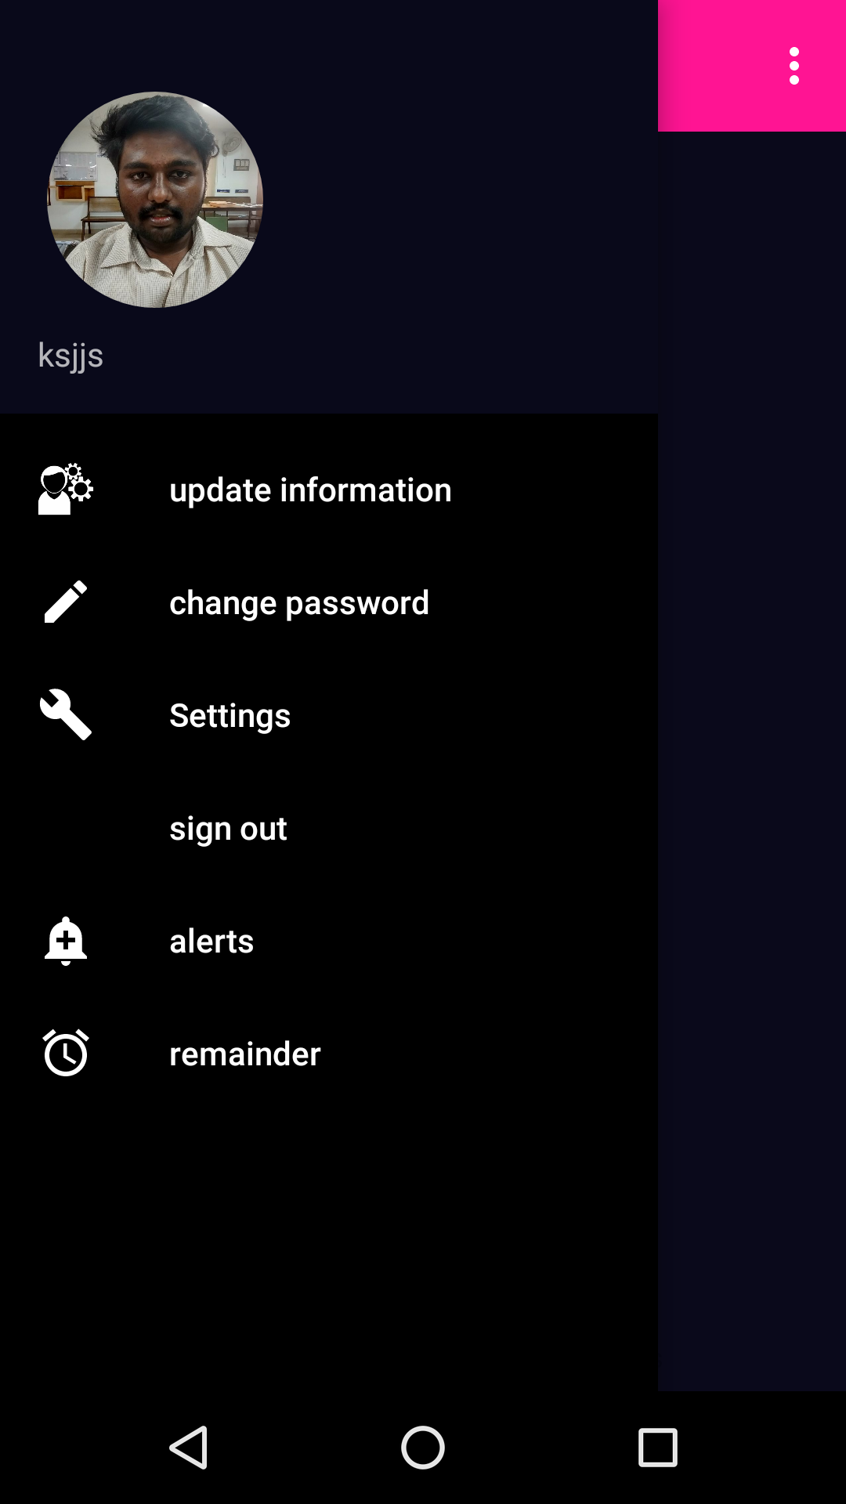



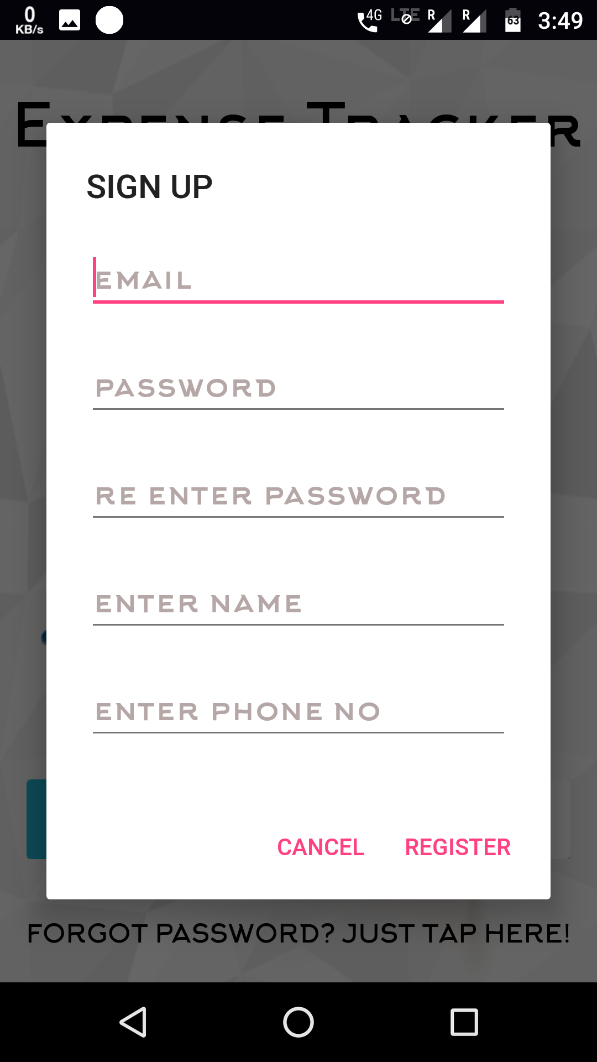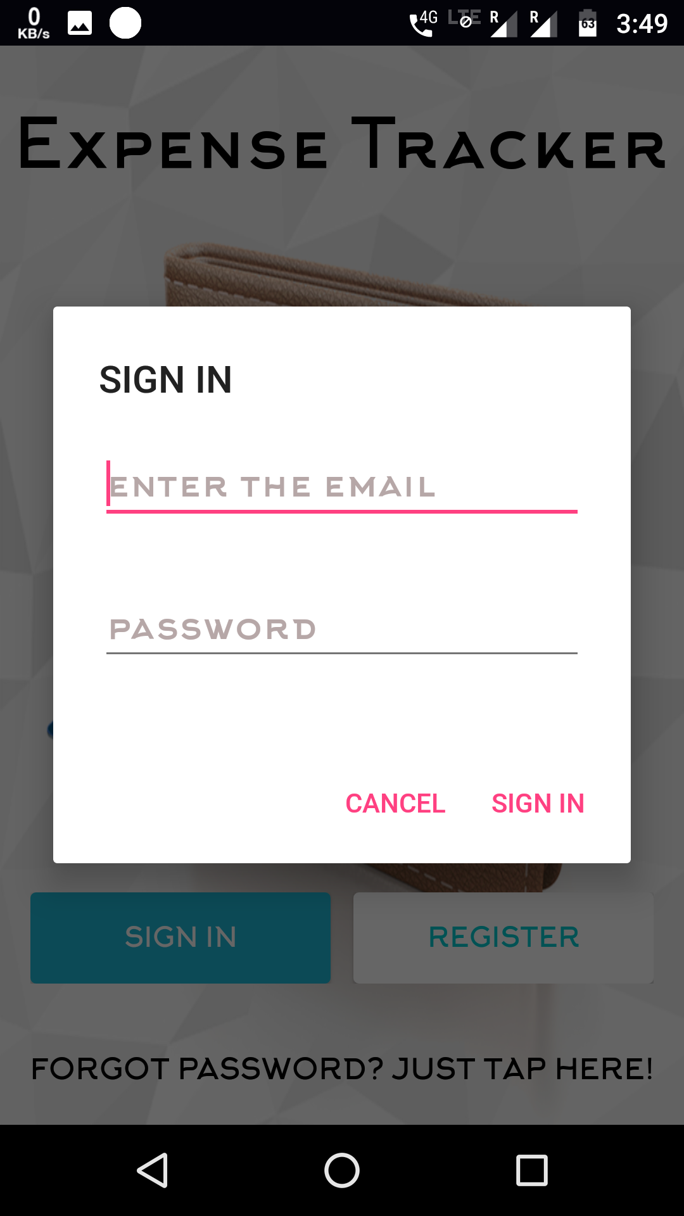

|  |  |
| --- | --- |
| USE-CASE | Profile setup |
| PRIMARY ACTOR | User |
| Goal in context | To store details of the user as entered by user |
| Pre-conditions | User must have an created and verified account |
| Trigger | User account is verified |
| Scenario | 1. The account is verified and redirected to a page to enter personal details.  2. The user enters name, age, DOB, gender, working place,addresss  3**.** The user clicks update.  4. The user details is stored and is redirected to dashboard page. |
| Exceptions | If verification fails the personal detail page doesn’t come up.  All details have to be filled. |
| Priority | **Essential, must be implemented** |
| When available | **First sprint** |

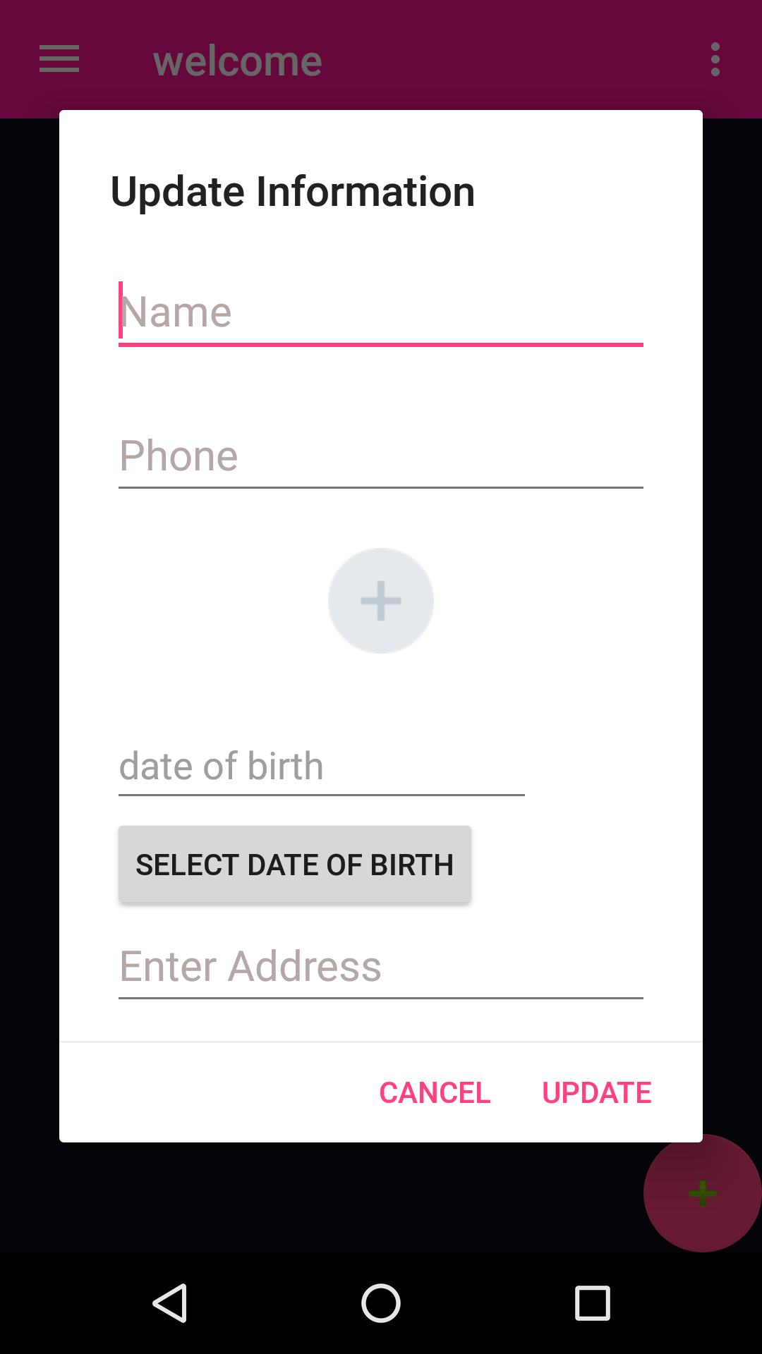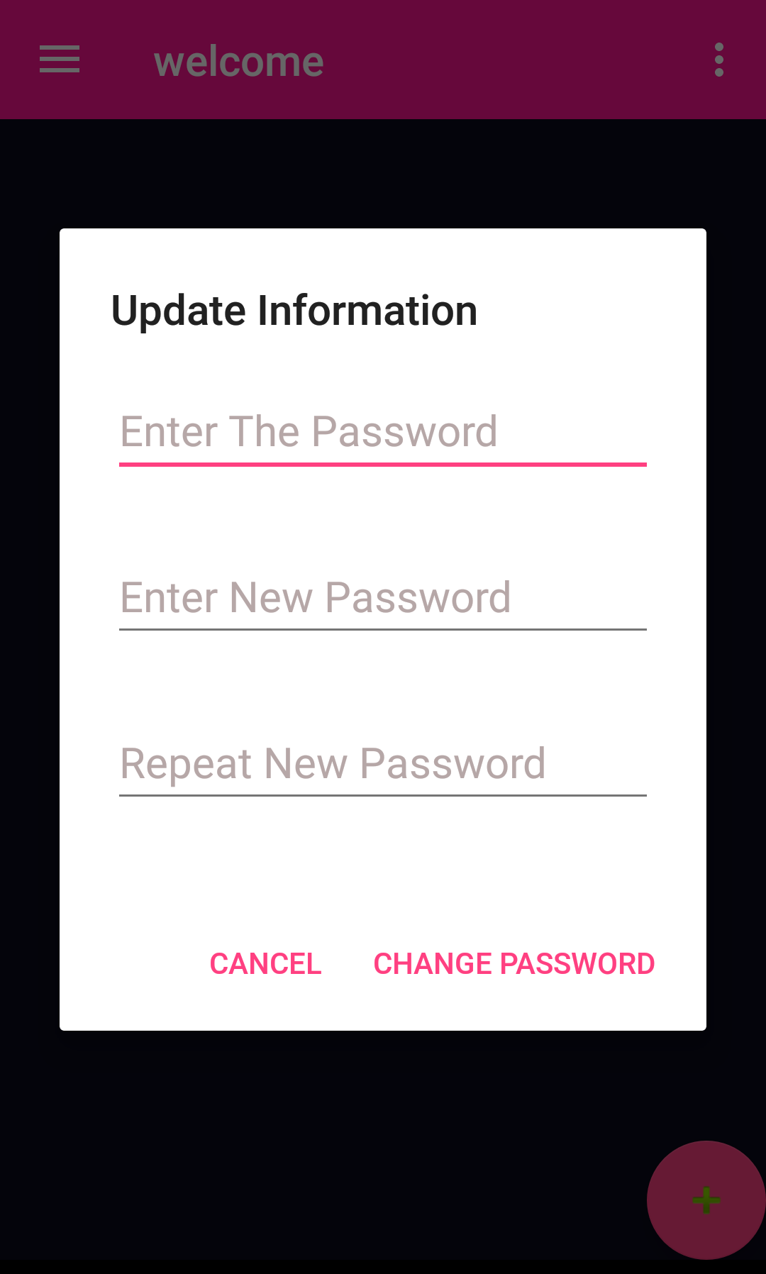

|  |  |
| --- | --- |
| USE-CASE | Expenses |
| PRIMARY ACTOR | User |
| Goal in context | **To enter the money spent on different category** |
| Pre-conditions | The user should have knowledge how to enter money in different categories |
| Trigger: | When “OK” button is clicked |
| Scenario | 1. User must select the insert button  2.Then it will ask add expense or add income  3.If User click add income we can enter the money he/she earn and date is selected automatically and user may/may not give the description  4.If we click add expense user can enter value,and he/she has to select category ,date updated automatically,and description may be provided. |
| Exceptions : | **2. The user did not fill every details** |
| Priority | **Essential, must be implemented** |
| When available | **First sprint** |
| Open Issues : |  |

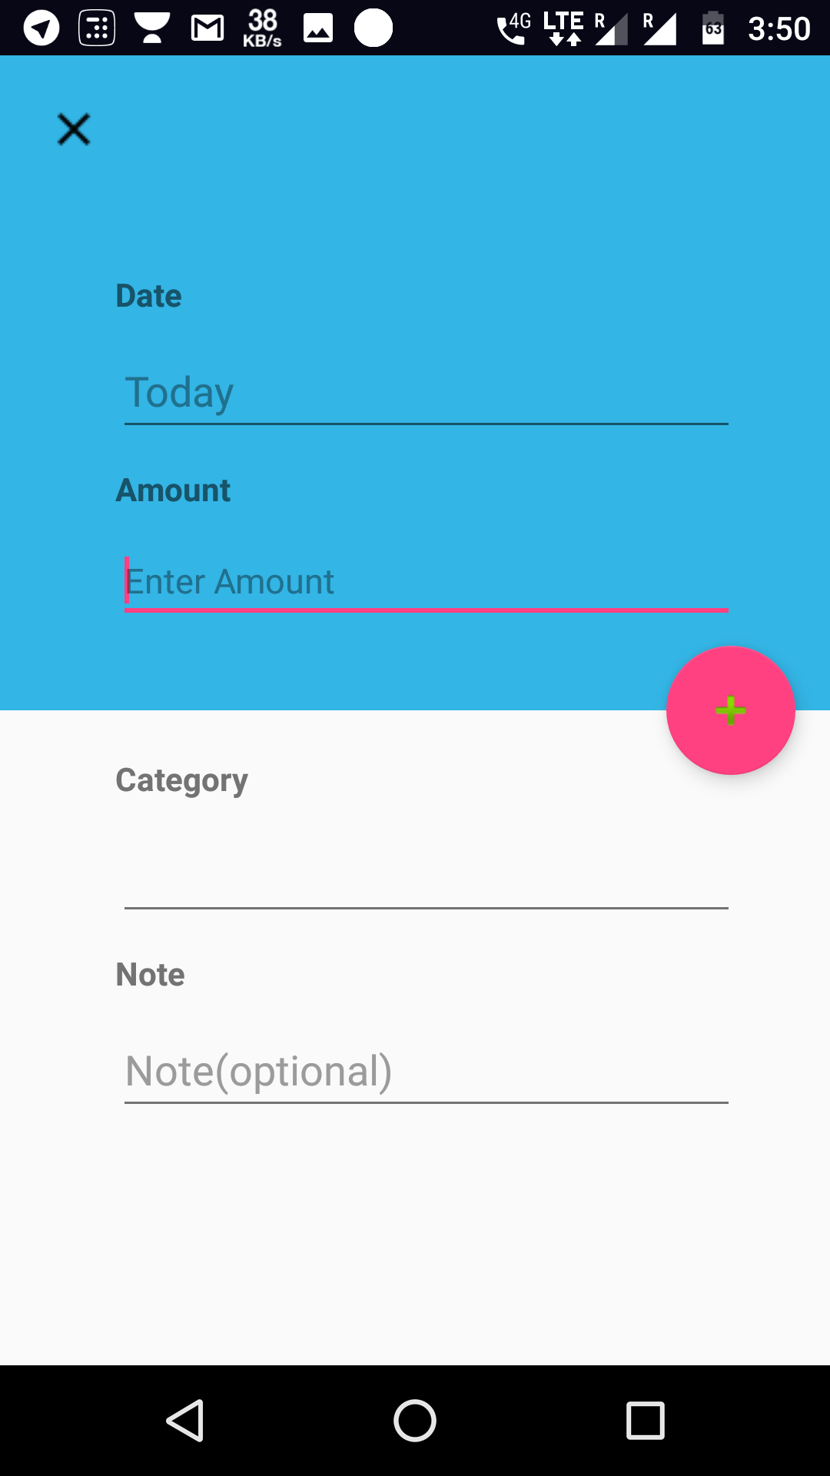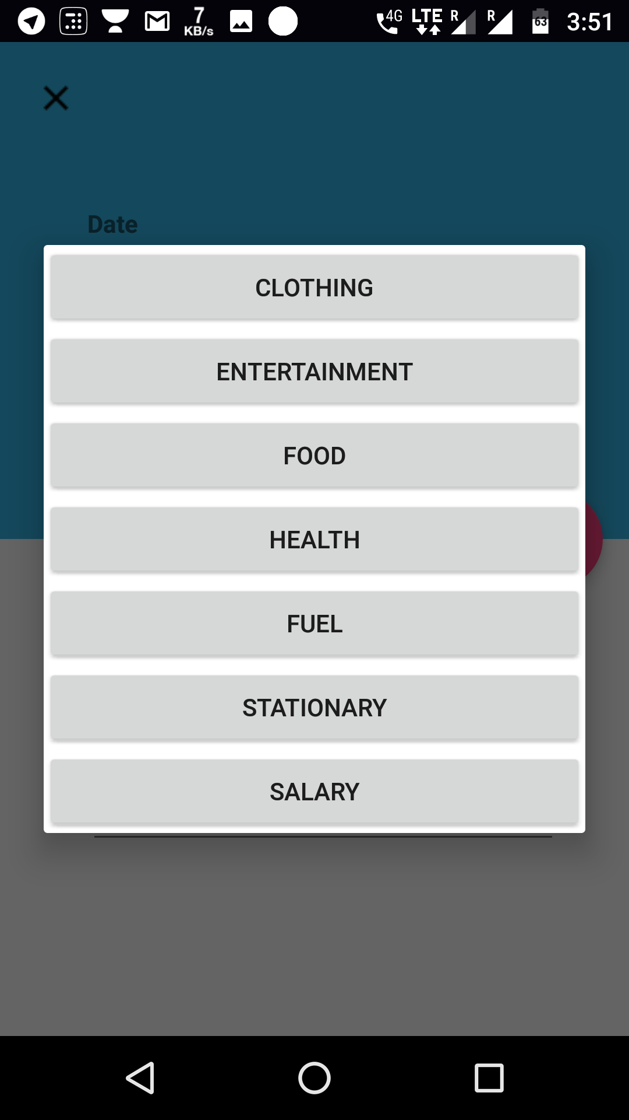

List of categories

**Sprint 2:**

We follow the agile model of software development. The product will be developed in Second sprint.

The Product Backlog are the following:

|  |  |
| --- | --- |
| Module | Purpose |
| Login Management(OTP only) | Manage the user access |
| Alerts | It helps user to be conscious about the expenses/transactions . User can off/on the alerts. |
| Graphs | It helps the user for the easy understanding of the expenses .it shoes different colors for the different categoriy like food ,clothing,etc…….. |

|  |  |
| --- | --- |
| USE-CASE | OTP |
| PRIMARY ACTOR | User |
| Goal in context | **For more security of the application** |
| Pre-conditions | The user should have knowledge how to use the OTP to secure privacy. |
| Trigger: | When “SEND VERIFICATION” button is clicked |
| Scenario | 1.At the first time when user sign it goes to the verification page.  2.Then it will send the OTP  3.when the OTP is received we enter the OTP  4.If the OTP is correct it goes to home page and if it wrong it shows an error message. |
| Exceptions : | **2. The user did not fill every details** |
| Priority | **Essential, must be implemented** |
| When available | **Second sprint** |
| Open Issues : |  |

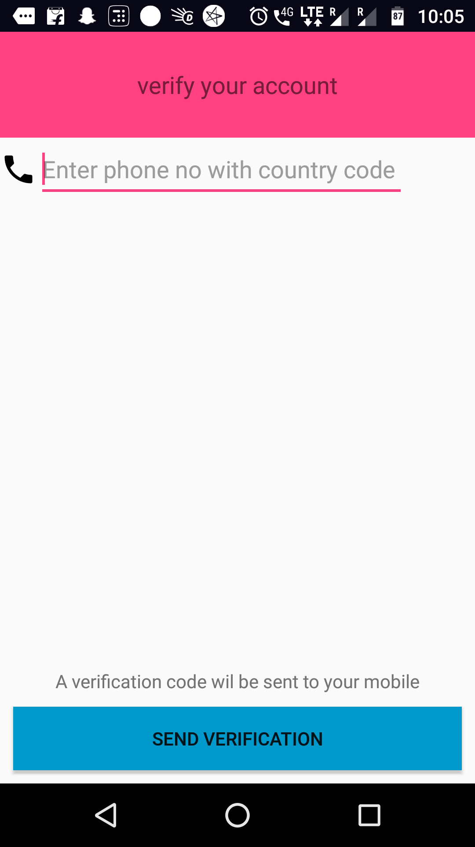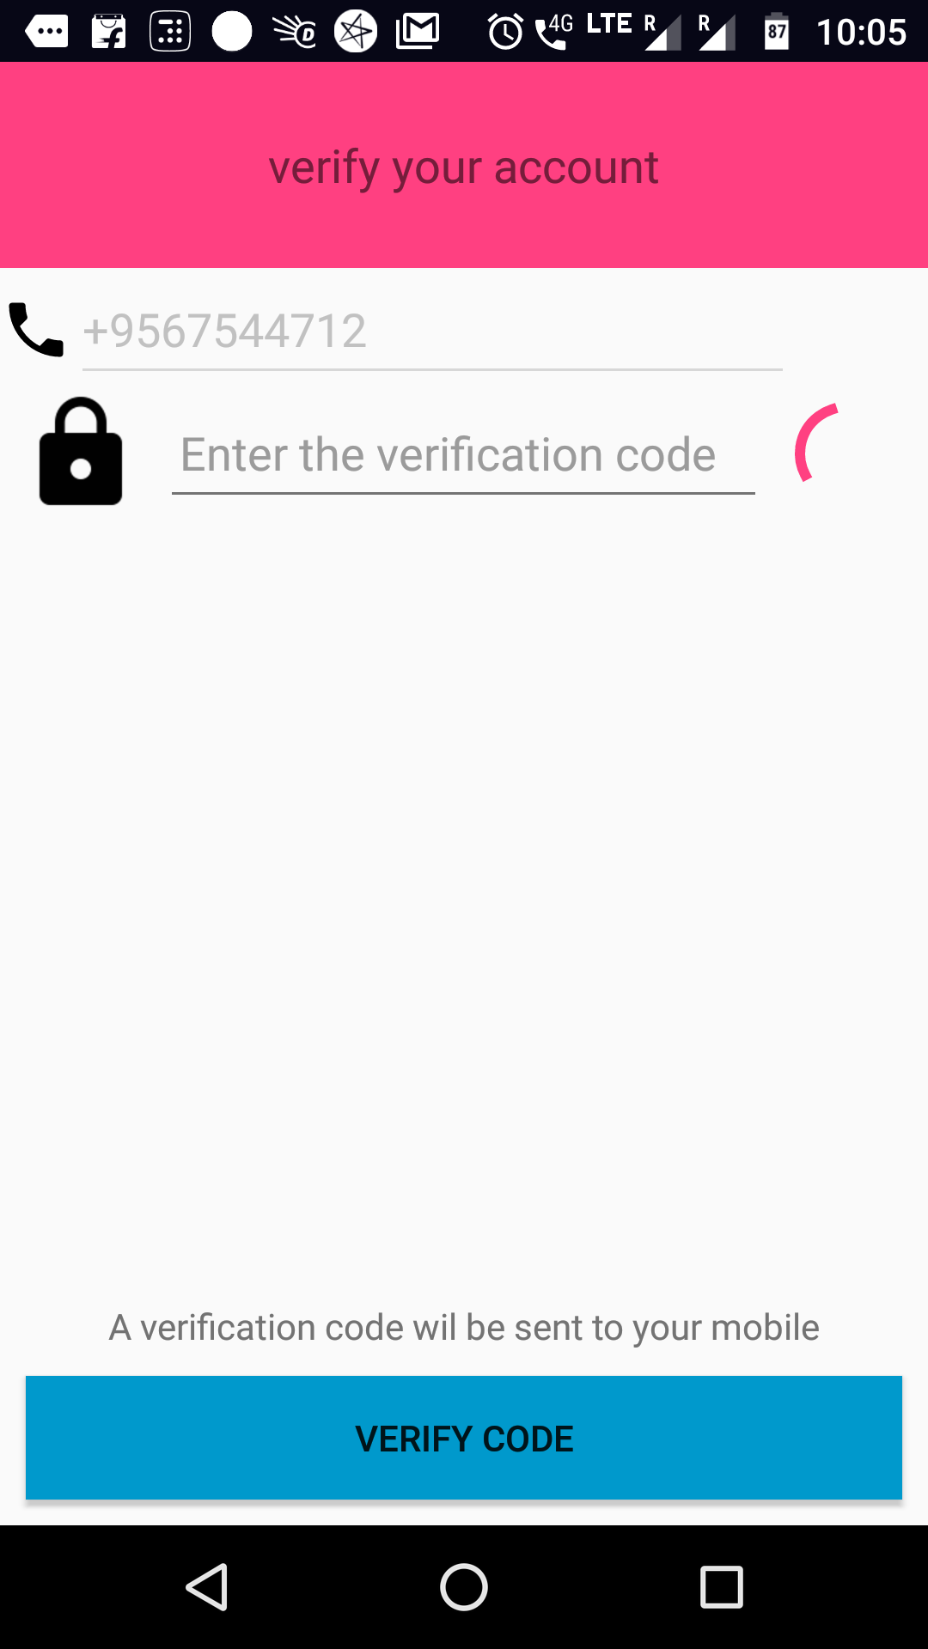

|  |  |
| --- | --- |
| USE-CASE | Graphs |
| PRIMARY ACTOR | User |
| Goal in context | **For easy understanding of the expenses** |
| Pre-conditions |  |
| Trigger: | When “GRAPHS” button is clicked |
| Scenario | 1.When the user goes to home page it shows an graphs button and when the user clicks the graphs button it shows an PI graph of expenses.  2.Different colors are given for different category like food ,clothing,hose hold etc…….  3.It shows the percentage of the expenses in the graph. |
| Exceptions : | **2. The user did not fill every details** |
| Priority | **Essential, must be implemented** |
| When available | **Second sprint** |
| Open Issues : |  |

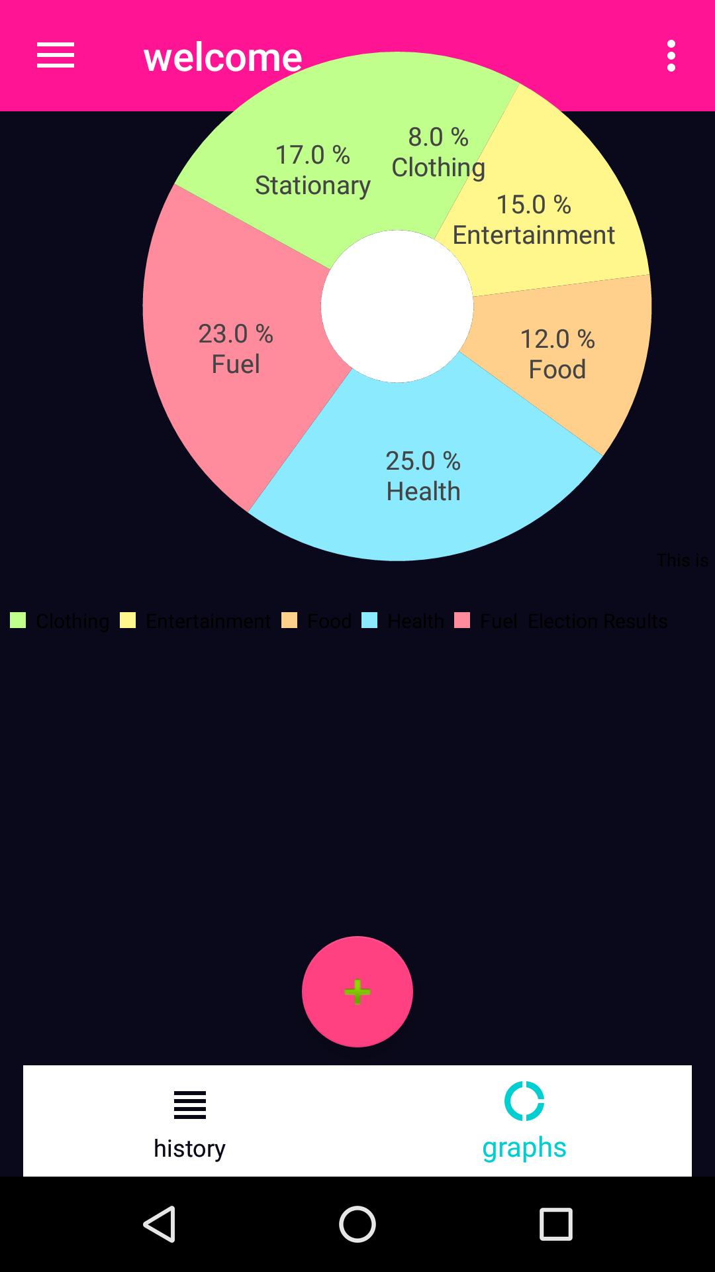

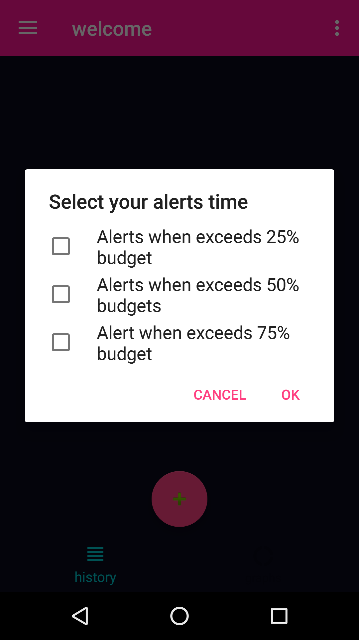

|  |  |
| --- | --- |
| USE-CASE | Alerts |
| PRIMARY ACTOR | User |
| Goal in context | **For being conscious about the expenses.** |
| Pre-conditions |  |
| Trigger: | When “ALERTS” button is clicked |
| Scenario | 1.When the user goes to home page and if he click menu button it shows many icons.  2. when the user click on alerts button it will send alerts on exceeding the maximum budget.  3.user can on/off the alerts. |
| Exceptions : | **2. The user did not fill every details** |
| Priority | **Essential, must be implemented** |
| When available | **Second sprint** |
| Open Issues : |  |

|  |  |
| --- | --- |
| USE-CASE | Reminder |
| PRIMARY ACTOR | User |
| Goal in context | **For the user convenience** |
| Pre-conditions |  |
| Trigger: | When “REMINDER” button is clicked |
| Scenario | 1.When the user goes to home page and if he click menu button it shows many icons.  2. when the user click on REMINDER button it will ask the user to to set the time to enter the expenses based on user convenience. |
| Exceptions : | **2. The user did not fill every details** |
| Priority | **Essential, must be implemented** |
| When available | **Second sprint** |
| Open Issues : |  |

